**Introduction**

A blast furnace is a type of metallurgical furnace used for smelting to produce industrial metals, generally iron, but also others such as lead or copper.

In a blast furnace, fuel, ores, and flux (limestone) are continuously supplied through the top of the furnace, while a hot blast of air (sometimes with oxygen enrichment) is blown into the lower section of the furnace through a series of pipes called tuyeres, so that the chemical reactions take place throughout the furnace as the material moves downward. The end products are usually molten metal and slag phases tapped from the bottom, and flue gases exiting from the top of the furnace. The downward flow of the ore and flux in contact with an up flow of hot, carbon monoxide-rich combustion gases is a counter current exchange and chemical reaction process.

The department is headed by GM Production. Operation of blast furnace and utilities such as raw material handling and charging system, Hot metal handling, Slag Drier, water management, and process development is managed by the department. Blast furnace operation and water management is looked after by HOD Production, RMHS and Hot metal handling is managed by Manager Hot metal handling. Process, Planning & Product Quality is headed by Manager- Product Quality.

The Major KPI’s for the production dept. are:

Reduction in Coke rate

Reduction in Operational downtime

Increase in Hot blast Temperature

Reduction in Cost of consumables

Reduction in off grade production and Skull

Water and energy Consumption

**Process Flow Chart**



**Systematic Layout of our operation**

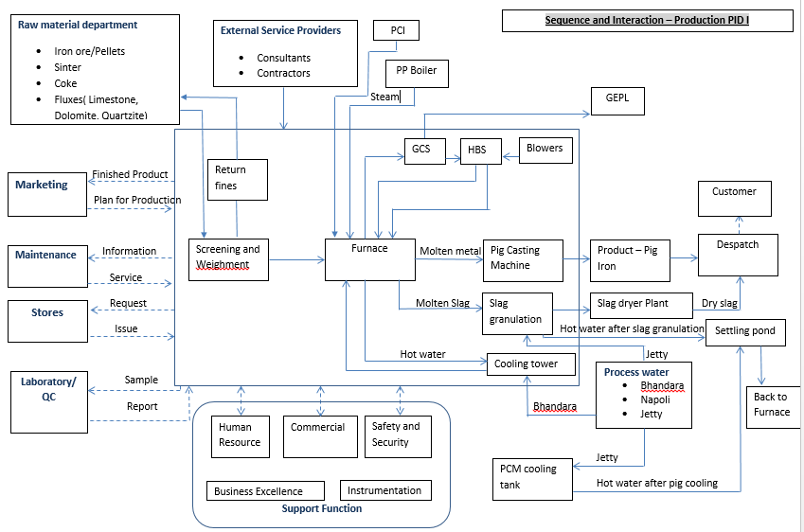

**Products and By-Products**

**Pig Iron**

Pig Iron is a product of Blast furnace operation. Natural Iron ore (Fe2O3) is reduced in the blast furnace to get Iron (Fe) in the form of liquid hot metal. It is having around 92-94% iron and other constituents are carbon (C), Silicon (Si) Manganese (Mn), Sulphur (S) and Phosphorous (P). Composition of all these elements determines the grade and application of the pig iron. Presently PID has classified three major Grades (Foundry, Basic & SG Grade) and sub-divided into 37 sub grades of pig iron. Liquid hot metal is further casted in small blocks of around 5-7 kgs.

**Slag**

Slag is the by-product of blast furnace process. Calcium Oxide (CaO) and Silicon Oxide (SiO2) are major components of slag thus making it a very good raw material for cement industry. Molten slag is granulated with water jet, Dried and Sold to cement industries around Amona.

**Skull**

This is semi-finished product generated during casting and tapping of liquid hot metal. It is segregated as per physical size and Fe content and sold accordingly. Skulls are graded into following

PCM Skull

Gholi: +3-50 mm size

Gholi: +1-3 mm size

Gholi: -1 mm size

Cast house debris: -20 mm Non-Magnetic

**Blast Furnace Gas (BFG)**

This is flue gas generated during the blast furnace operation. This gas is passed through various scrubbers in gas cleaning system and further used for power generation in captive power plant. BFG has around 20-23% of carbon monoxide and having calorific value of around 700-800 K. Cal. BFG is also internally used in Hot Blast Stoves for heating blast furnace input air, In 5TPH boiler for catering steam requirement of the process and at slag drier Plant.

|  |  |  |
| --- | --- | --- |
| **Prepared By:**  Control Room In charge | **Reviewed & Issued By:**  Management Representative | **Approved By:**  Head – Operations PID1 |
| **Signature:** | **Signature:** | **Signature:** |
| **Review Date: 08.08.2022** | **Review Date: 08.08.2022** | **Review Date: 08.08.2022** |